WorldEngine GUI

**Table of contents**

Introduction 3

What's new 7

Licences 10

Getting Started 13

System requirements 22

Getting help 25

Maps Tab 28

The Maps 31

Biomes 34

Elevation 37

Grayscale Heightmap 40

Humidity 43

Icecaps 46

Normal Map 49

Ocean 52

Permeability 55

Precipitation 58

Rivers 61

Satellite 64

Scatter Plot 67

Temperature 70

Wind 73

Map Options Tab 76

Map Parameters 79

Erosion 82

Humidity 85

Hydrology 88

Ice Caps 91

Irrigation 94

Permeability 97

Precipitation 100

Temperature 103

Wind 106

World Options Tab 109

Ancient Map Options Tab 119

Ancient World Map 123

Menus 126

File 129

Zoom 132

World 135

3D View 138

Help 141

Toolbars 144

**Introduction**

# GUI for WorldEngine

Hello and welcome to my GUI for WorldEngine (<http://world-engine.org/>).

Firstly, I'd just like to say a big "THANK YOU" to Bret Curtis and Federico Tomassetti, without whom we wouldn't have WorldEngine, and this GUI wouldn't exist! For those of you who aren't familiar with WorldEngin, don't worry, because this Help File will hopefully get you up and running in no time.

OK, that's enough rambling, let's get down to introducing the star of this particular show:

**WorldEngine**

WorldEngine is a fantastic piece of software that allows you to generate realistic worlds using various simulations, such as plate tectonics, rainfall, erosion, etc. It is mainly written in Python and can be run from the command line. But, who likes to use the command line nowadays? Not me! So, that's why I created this GUI in PyQt to allow you much more freedom to create your worlds.

As stated on the WorldEngine website:

"**Worlds are generated using plate simulations, erosion, rain shadows, Holdridge life zones model and plenty of other phenomenon.**"

In fact, WorldEngine contains the following simulations of various real-world conditions:

* Elevation
* Oceans
* Temperature
* Precipitation
* Erosion
* Hydrology
* Irrigation
* Humidity
* Permeability
* Biomes
* Icecaps
* Wind

As you can see, the list is pretty comprehensive and will allow you to create some reasonably realistic worlds.

The Command Line version of WorldEngine allows you to create several **Maps** to show off various aspects of your world:

* Ancient World (this is a Map of your world drawn in a way that follows the old Asian Map traditions)
* Elevation (a colourful Map showing the various heights of the land in your world)
* Precipitation (a Map showing where rain is likely to fall in your world, and how much)
* Temperature (a Map showing the varying temperatures of your world)
* Biomes (a Map showing the different types of land in your world)
* Ocean (a Map showing the oceans of your world)
* Icecaps (a Map showing the ice caps of your world)
* Rivers (a Map showing all the rivers and lakes of your world)
* Grayscale Heightmap (very useful if you want to use your world in a game engine)
* Satellite (a Map showing your world as it would look from a satellite in orbit)
* Scatter Plot (a Map that shows a scatter plot of the humidity & temperature across your world)

To this list, I have also added the following:

* Wind (a Map showing the winds that blow across your world)
* Permeability (a Map showing the permeability of your world)
* Humidity (a Map showing the humidity across your world)
* Normal Map (a Normal Map of your world - for use in game engines)

To see examples of each of the Maps, just click on the links above, or go to the relevant Map page.

Well, I think that's enough of an intro, so feel free to select options in the Table of Contents to delve deeper into WorldEngine and this GUI.

*Created with the Personal Edition of HelpNDoc:* [*Create help files for the Qt Help Framework*](http://www.helpndoc.com/feature-tour/create-help-files-for-the-qt-help-framework)

**What's new**

# Initial Release - March 2017

Since this is the very first official release of my GUI for WorldEngine, it's all new!

*Created with the Personal Edition of HelpNDoc:* [*Free help authoring environment*](http://www.helpndoc.com/help-authoring-tool)

**Licences**

# Licences

**WorldEngine**

WorldEngine is available under the MIT License (see **LICENCE (WorldEngine).txt**).

**Pi3D**

Pi3D is available under the MIT License (see **LICENCE (Pi3D).txt**):

**WorldEngine GUI**

WorldEngine GUI is also available under the MIT Licence (see below and **LICENCE.txt**):

**The MIT License (MIT)**

Copyright (c) 2016-2017 SpinalSoft (AU)

Permission is hereby granted, free of charge, to any person obtaining a copy of this software and associated documentation files (the "Software"), to deal in the Software without restriction, including without limitation the rights to use, copy, modify, merge, publish, distribute, sub-licence, and/or sell copies of the Software, and to permit persons to whom the Software is furnished to do so, subject to the following conditions:

The above copyright notice and this permission notice shall be included in all copies or substantial portions of the Software.

THE SOFTWARE IS PROVIDED "AS IS", WITHOUT WARRANTY OF ANY KIND, EXPRESS OR IMPLIED, INCLUDING BUT NOT LIMITED TO THE WARRANTIES OF MERCHANTABILITY, FITNESS FOR A PARTICULAR PURPOSE AND NONINFRINGEMENT. IN NO EVENT SHALL THE AUTHORS OR COPYRIGHT HOLDERS BE LIABLE FOR ANY CLAIM, DAMAGES OR OTHER LIABILITY, WHETHER IN AN ACTION OF CONTRACT, TORT OR OTHERWISE, ARISING FROM, OUT OF OR IN CONNECTION WITH THE SOFTWARE OR THE USE OR OTHER DEALINGS IN THE SOFTWARE.

**Icons**

All Icons used in this GUI are from **cc mono icon set** from <http://www.iconfinder.com/iconsets/cc_mono_icon_set> by [Gentleface.com](http://www.gentleface.com) under [Creative Commons (Attribution-Noncommercial 3.0 Unported)](http://creativecommons.org/licenses/by-nc/3.0/), except for the 3D, & WINDOW icons which are attributable as follows:

"Icon made by Freepik from <http://flaticon.com>"

**Stylesheet**

The Qt stylesheet used in this GUI is a modified version of **Qt Dark Orange** from <http://tech-artists.org/forum/showthread.php?2359-Release-Qt-dark-orange-stylesheet> by LoneWolf.

*Created with the Personal Edition of HelpNDoc:* [*Easily create Qt Help files*](http://www.helpndoc.com/feature-tour)

**Getting Started**

# Getting Started

As I stated in the Introduction, WorldEngine can be run from the Command Line. There are several examples on the WorldEngine website, so I'll just show you one here:

*worldengine world -s 1 -n seed1*

As you can see above, it's pretty simple to generate a world. However, since there are over 10 possible options in the Command Line version, the text can get quite long and complicated.

This is where my GUI comes in. Not only does it handle all of the Command Line options, but I have changed the WorldEngine code to allow access to many, many more options, which will enable you to create much more personalised worlds.

As an example, the options available for the Permeability Simulation are shown below (normally these would be hard coded into WorldEngine):

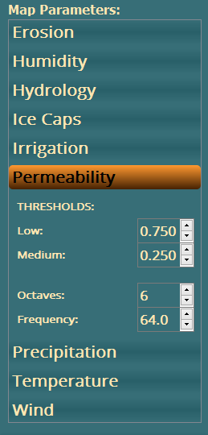

The best way to run my GUI is to get hold of a copy of PyCharm Community Edition (<http://www.jetbrains.com/pycharm/download/>) and load up the project that you downloaded with this Help File. Then it's simply a matter of clicking on **Run**, then **Run** and selecting the **main.py** file. This should run the GUI and you should now see this on your screen (NB: I will be trying to create a Windows executable, but I don't seem to have much luck getting Pythonic projects to create an exe):

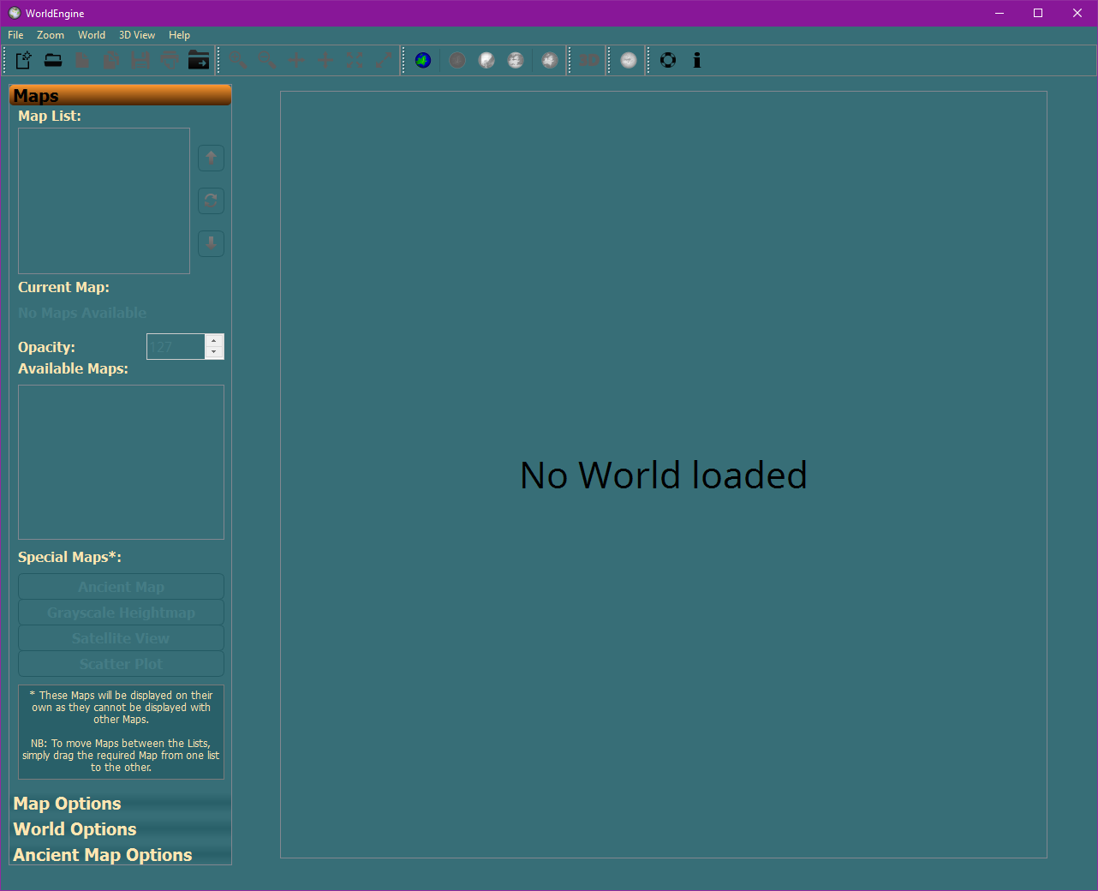

Hopefully this is a fairly standard Windows UI, so you should be familiar with how to use it and a lot of the available options. To go into more detail about the available menus, buttons and other options, please select the relevant heading in the **Table of Contents**.

The next step is to create a World.....

For the purposes of this quick intro, we won't be touching any of the options, but just going straight to creating a World. So, simply click on the **World Options** tab on the left hand side of the UI, enter a value of **60247** in the **World Seed** option, select **Yes** for the **Enable Verbose Messages?** option and then click on the button labelled **Generate World and All Maps**.

If everything is working correctly, then you should see a pop-up like this:

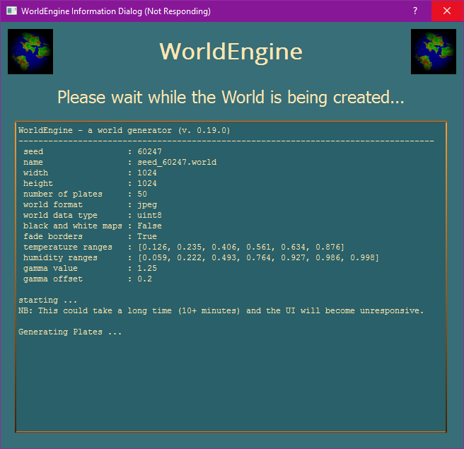

As you can see, this pop-up displays some basic information about the World you are creating and tells you that WorldEngine is now starting to work. NB: The UI will become unresponsive whilst the Simulations are running.

After a fairly long time (10+ minutes on my laptop with the above settings), you should see this in the pop-up:

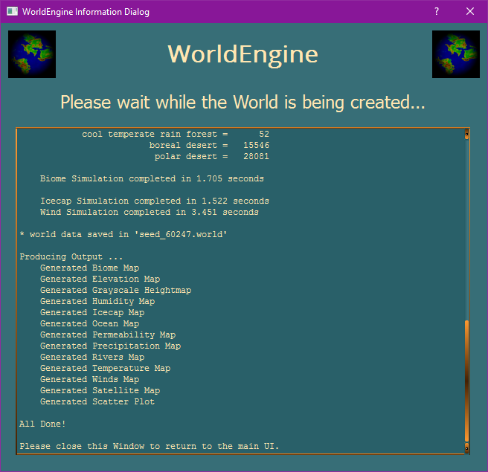

Now, simply click on the **X** in the top right of the pop-up and you should now see this in the Main Window:

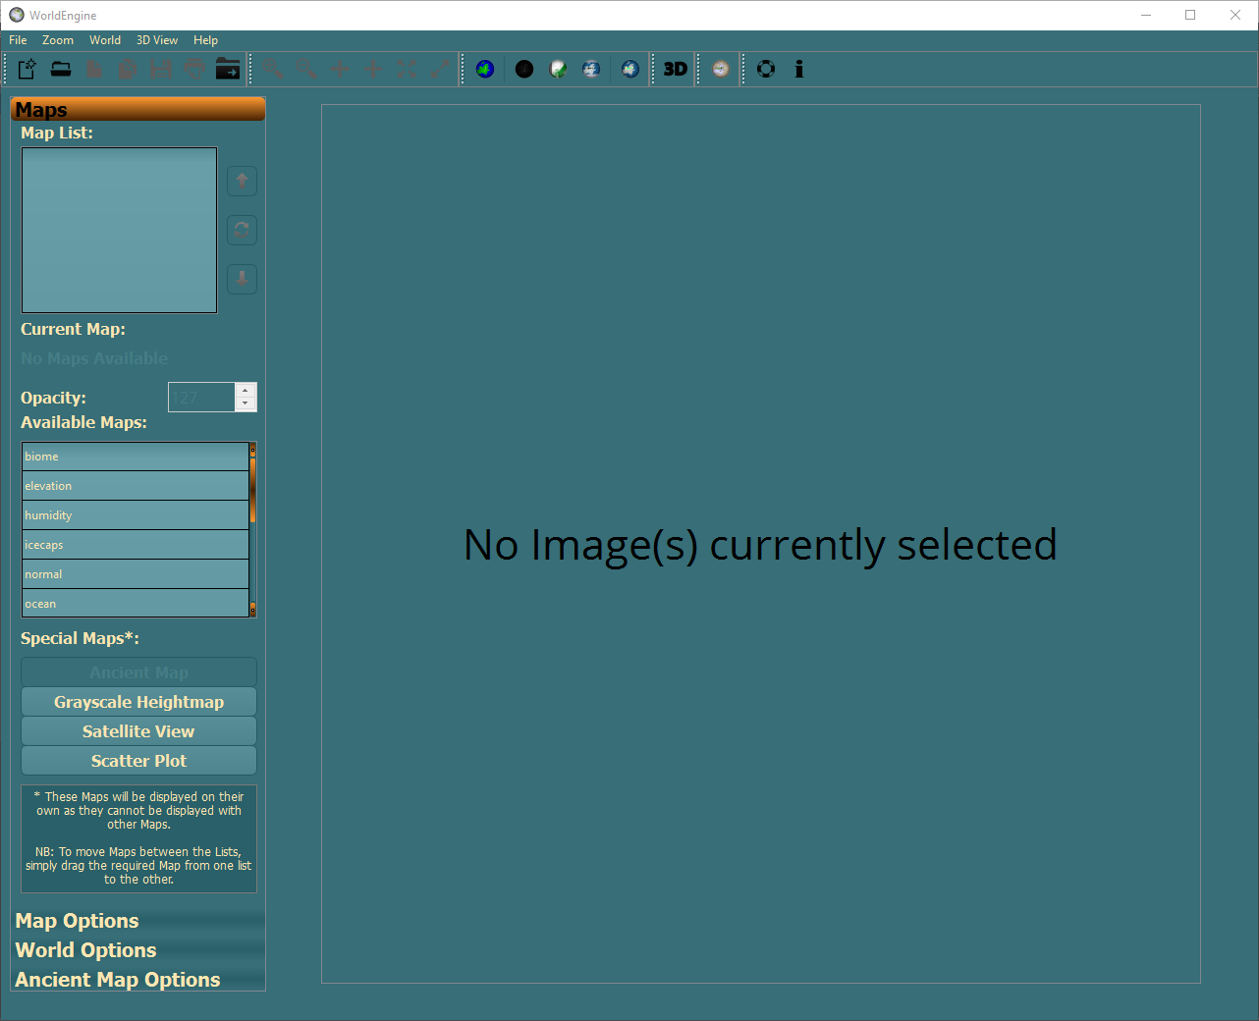

As you can see, Creating (or Loading, as it's just the same) a World populates the **Available Maps** list and also opens up the **Special Maps\*** buttons (if the relevant Map exists).

To view one of the **Special Maps\***, simply click the button and you should see something like this:

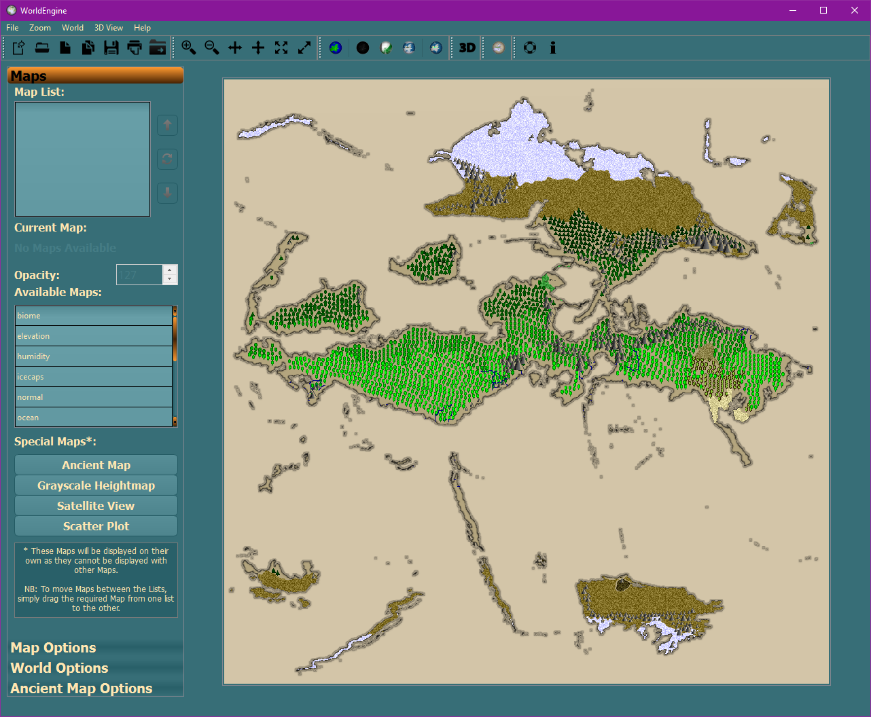

To view the other Maps, you can simply drag and drop them between the **Map List** and **Available Maps** lists.

NB: There is an option to change the **Opacity** of each Map (the LOWEST Map in the **Map List** will ALWAYS have an **Opacity** of **255**, and this doesn't apply to the **Special Maps\***) so that you can build up unlimited different views in the Main Viewport.

Once you have moved one, or more, Maps to the **Map List**, simply click on the **Refresh** button () to regenerate the view in the Main Viewport:

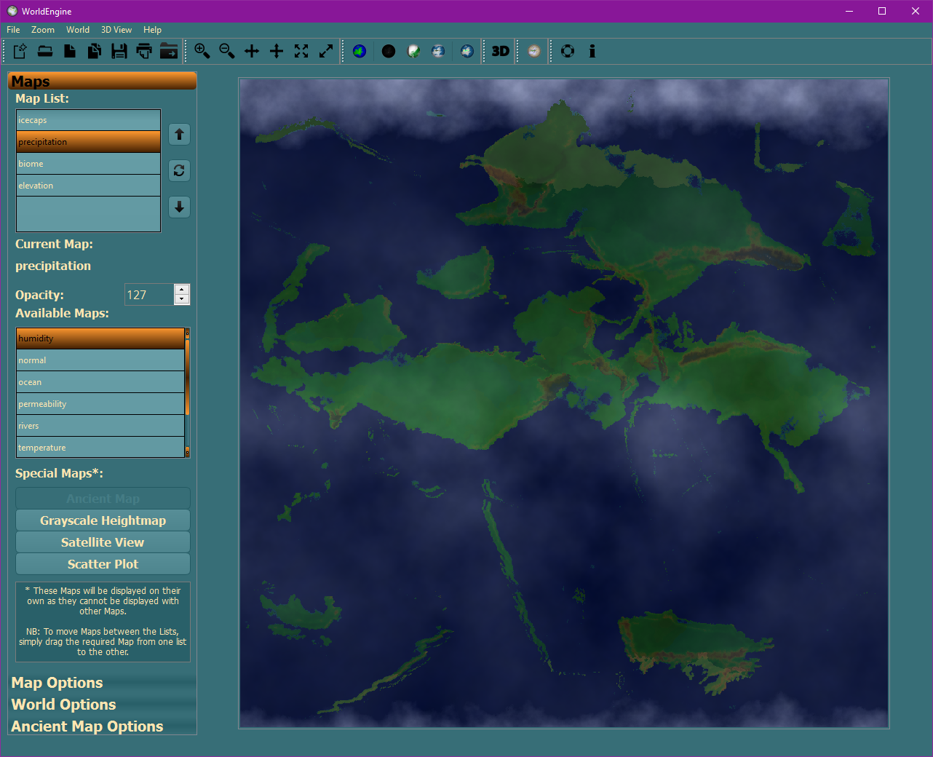

Finally, to change the order of the Maps, simply select the Map and click on the **Up**, or **Down**, arrow immediately above/below the **Refresh** button.

Well, that's enough of an introduction, so have fun and if you have any issues, please let me know (Getting Help) and I'll try to assist as much as possible.

*Created with the Personal Edition of HelpNDoc:* [*Easily create EBooks*](http://www.helpndoc.com/feature-tour)

**System requirements**

# System Requirements

Now this is where it gets really interesting.....

You will need at least the following:

Python v2.7.9 NB: Python 3+ does not work AFAIK

and the following Python Libraries: NB Ensure they are for the correct version of Python

configparser2 v4.0.0

gdal v2.1.0

h5py v2.5.0

numpy v1.11.0

noise v1.2.2

pi3d v2.18

pillow v3.2.0

protobuf v3.0.0b3

pyface v5.1.0

pygame v1.9.2a0

pyopengl-accelerate v3.1.1

pyopengl v3.1.1a1

pyplatec v1.4.0

pypng v0.0.18

pyqt4 v4.11.4

pywin32 v220

six v1.10.0

If you are using PyCharm, then it will usually let you know if any required Libraries are missing.

Finally, you MUST also make sure that your **qt.conf** file (in your Python directory) contains something similar to the following:

[Paths]

Prefix = Lib/site-packages/PyQt4

Binaries = Lib/site-packages/PyQt4

Plugins = Lib/site-packages/PyQt4/plugins

The MOST important one (well, the one that is probably missing) is the line that starts "Plugins = ...". If this is NOT present then you will only be able to load png files.

Also, it's a good idea to check that you have the following imageformat dlls in your "??:\Python27\Lib\site-packages\PyQt4\plugins\imageformats" folder:

qgif4.dll

qico4.dll

qjpeg4.dll

qmng4.dll

qsvg4.dll

qtga4.dll

qtiff4.dll

Not all are required for this WorldEngine GUI, but it's better to be safe than sorry!

*Created with the Personal Edition of HelpNDoc:* [*Easily create iPhone documentation*](http://www.helpndoc.com/feature-tour/iphone-website-generation)

**Getting help**

# Getting Help

I know that there will be subtle bugs in this GUI, as anything of this size/complexity is very difficult for one person to fully test :(

But, there are a few ways to get help with both WorldEngine itself and this GUI.

For WorldEngine, you can check out it's [website](http://world-engine.org/), it's [GitHub page](http://github.com/Mindwerks/worldengine) , it's [documentation](http://worldengine.readthedocs.io/en/latest/) and also it's [Google Group](http://groups.google.com/forum/?hl=en#!forum/worldengine).

As for the GUI itself, there is really only the [GitHub page](http://github.com/Shando/WorldEngine_UI/) and the WorldEngine [Google Group](http://groups.google.com/forum/?hl=en#!forum/worldengine) (which I do check occasionally).

Regards

Shando

*Created with the Personal Edition of HelpNDoc:* [*Easy EBook and documentation generator*](http://www.helpndoc.com)

**Maps Tab**

# Maps

Pretty much all of the **Maps** tab has already been covered in Getting Started, so I won't go into any more detail here.

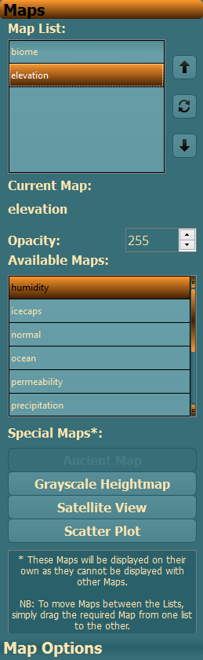

*Created with the Personal Edition of HelpNDoc:* [*Easily create CHM Help documents*](http://www.helpndoc.com/feature-tour)

**The Maps**

# Maps

In total there are 15 Maps that can be generated from within the UI:

Ancient World

Biomes

Elevation

Grayscale Heightmap

Humidity

Icecaps

Normal Map

Ocean

Permeability

Precipitation

Rivers

Satellite

Scatter Plot

Temperature

Wind

*Created with the Personal Edition of HelpNDoc:* [*Free EBook and documentation generator*](http://www.helpndoc.com)

**Biomes**

# Biomes

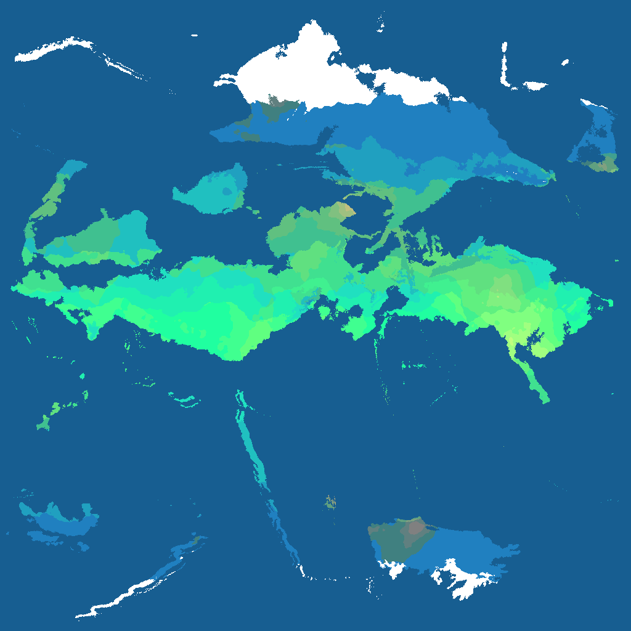

*Created with the Personal Edition of HelpNDoc:* [*Easy CHM and documentation editor*](http://www.helpndoc.com)

**Elevation**

# Elevation

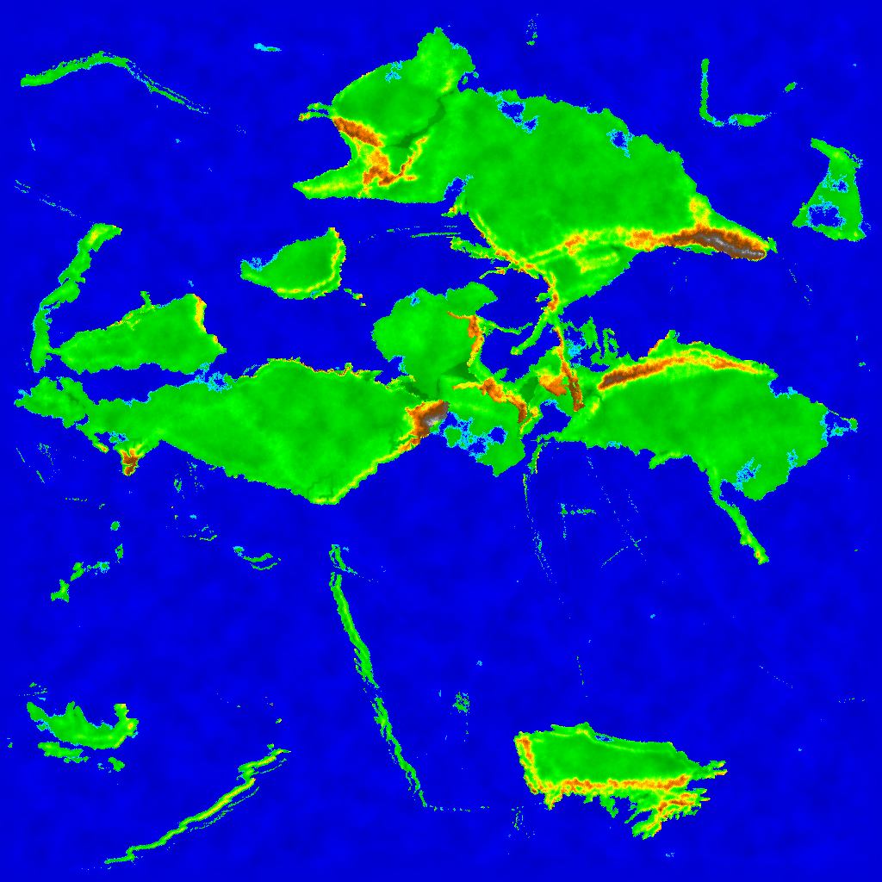

*Created with the Personal Edition of HelpNDoc:* [*Full-featured Help generator*](http://www.helpndoc.com/feature-tour)

**Grayscale Heightmap**

# Grayscale Heightmap

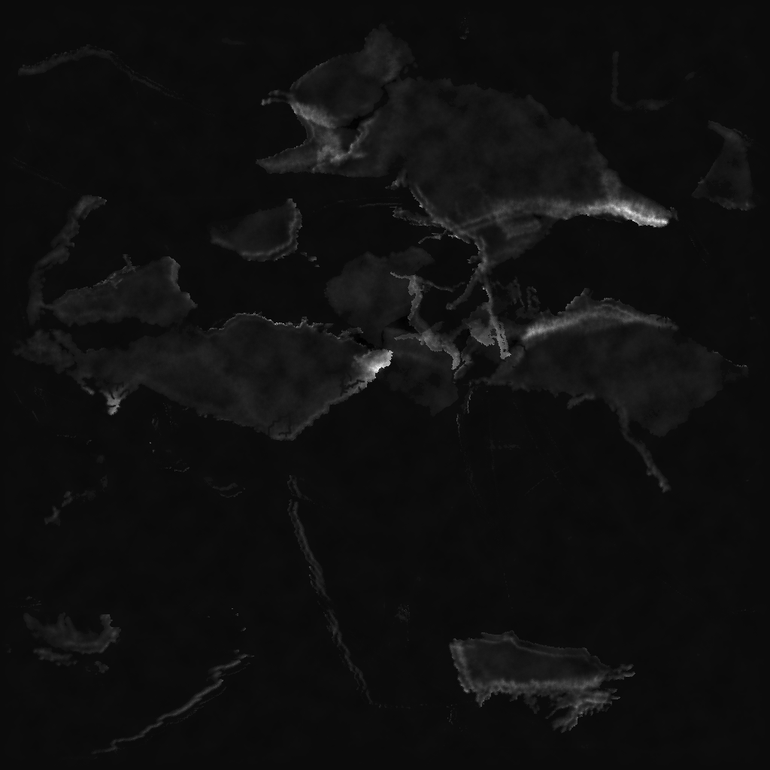

*Created with the Personal Edition of HelpNDoc:* [*Create HTML Help, DOC, PDF and print manuals from 1 single source*](http://www.helpndoc.com/help-authoring-tool)

**Humidity**

# Humidity

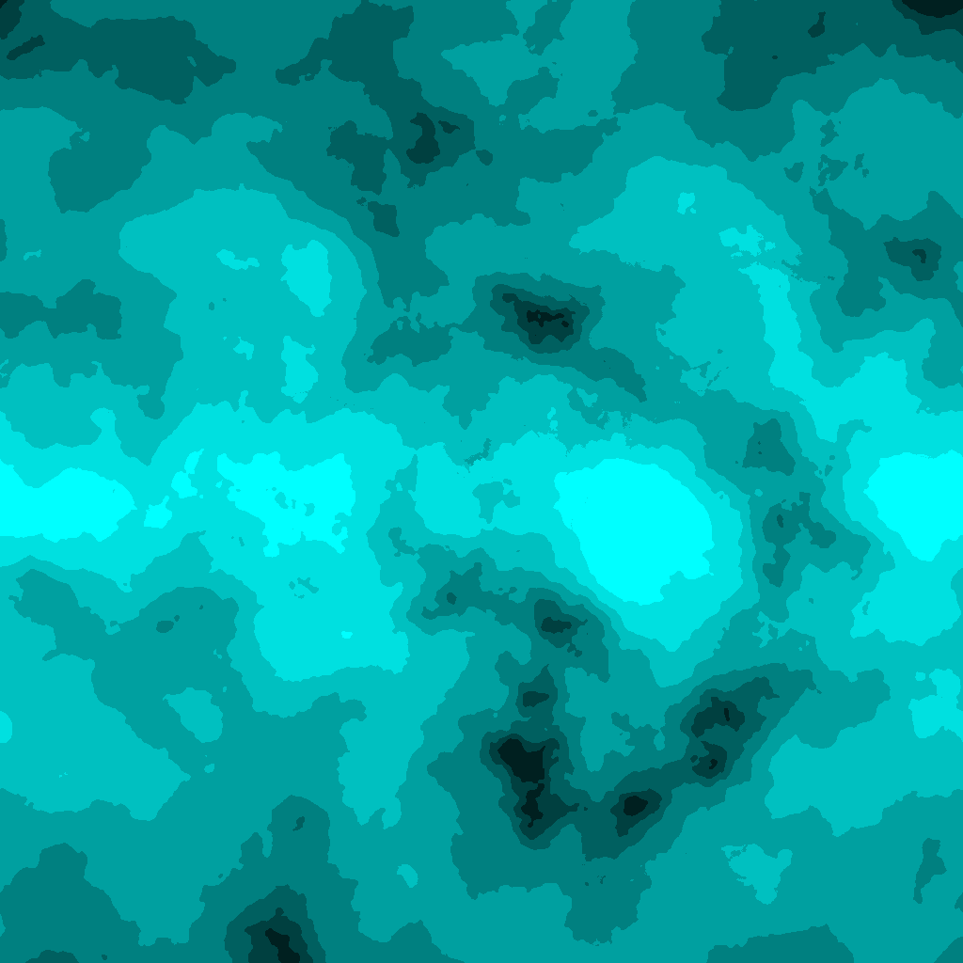

*Created with the Personal Edition of HelpNDoc:* [*Easily create CHM Help documents*](http://www.helpndoc.com/feature-tour)

**Icecaps**

# Icecaps

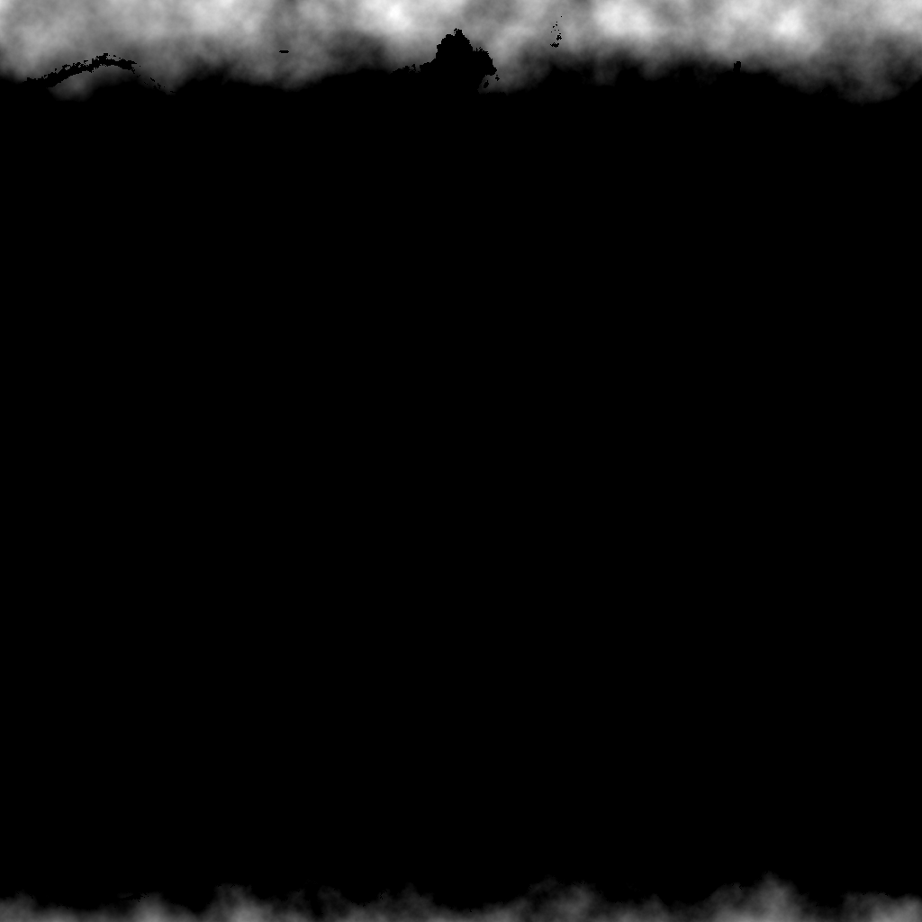

*Created with the Personal Edition of HelpNDoc:* [*Create cross-platform Qt Help files*](http://www.helpndoc.com/feature-tour/create-help-files-for-the-qt-help-framework)

**Normal Map**

# Normal Map

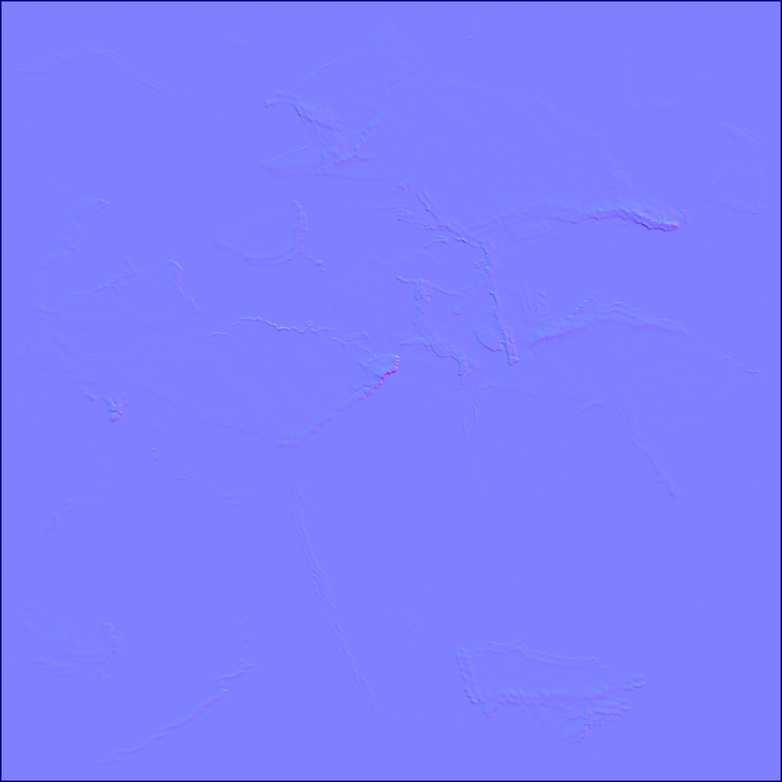

*Created with the Personal Edition of HelpNDoc:* [*Create help files for the Qt Help Framework*](http://www.helpndoc.com/feature-tour/create-help-files-for-the-qt-help-framework)

**Ocean**

# Ocean

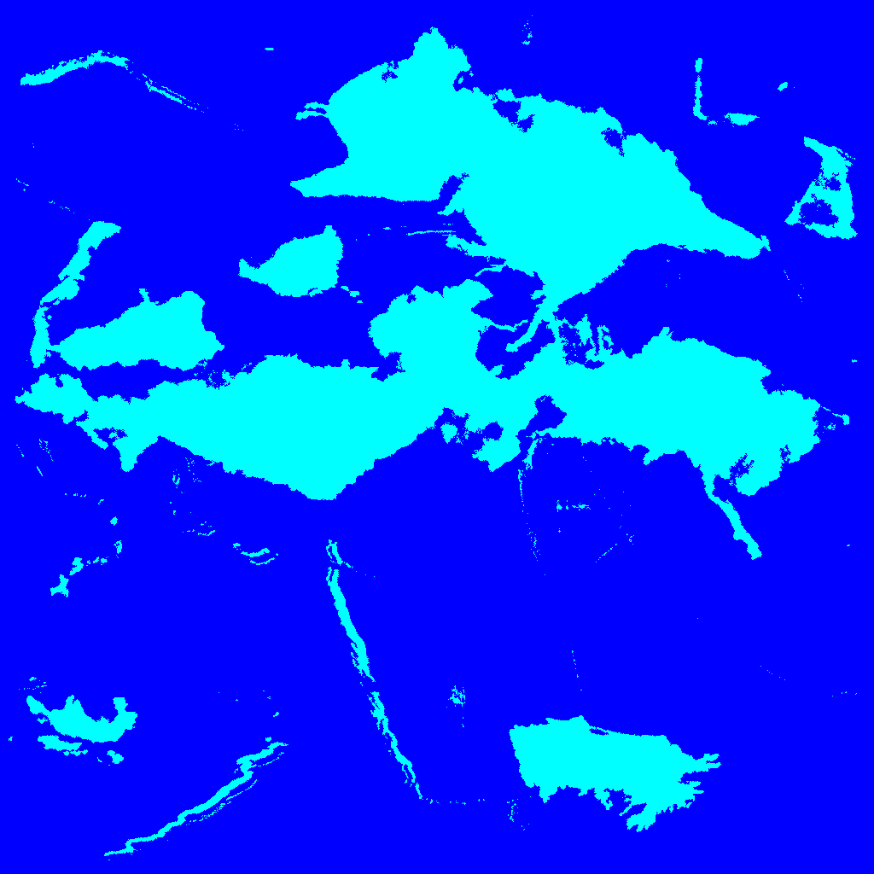

*Created with the Personal Edition of HelpNDoc:* [*Easy to use tool to create HTML Help files and Help web sites*](http://www.helpndoc.com/help-authoring-tool)

**Permeability**

# Permeability

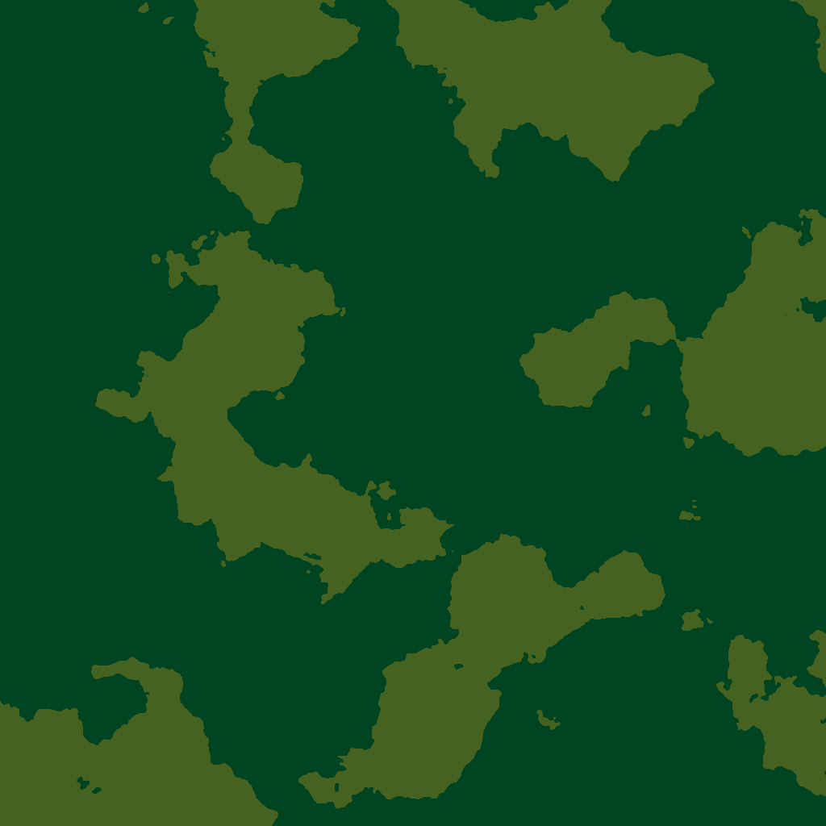

*Created with the Personal Edition of HelpNDoc:* [*Free Web Help generator*](http://www.helpndoc.com)

**Precipitation**

# Precipitation

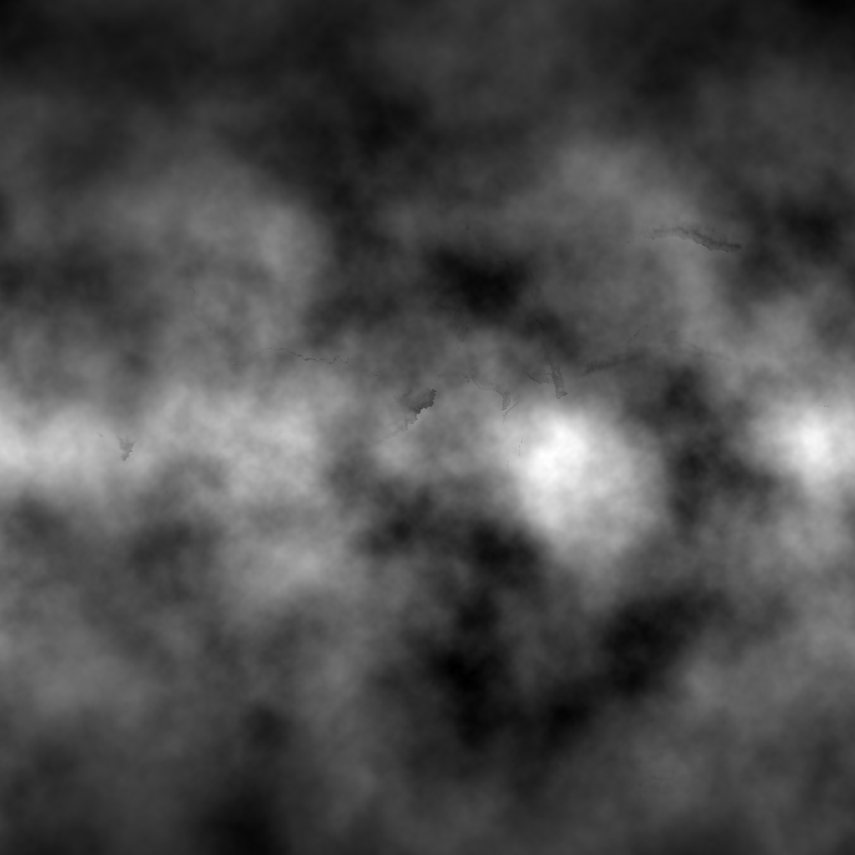

*Created with the Personal Edition of HelpNDoc:* [*Create iPhone web-based documentation*](http://www.helpndoc.com/feature-tour/iphone-website-generation)

**Rivers**

# Rivers

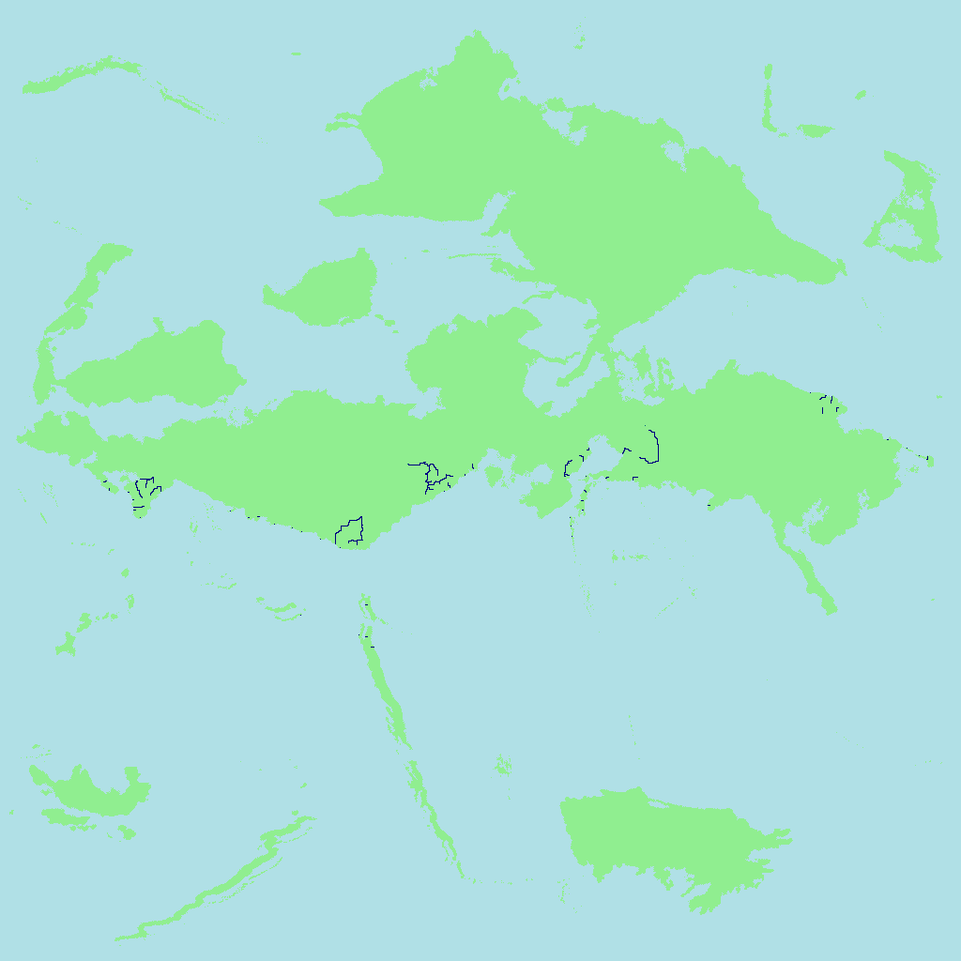

*Created with the Personal Edition of HelpNDoc:* [*Easily create iPhone documentation*](http://www.helpndoc.com/feature-tour/iphone-website-generation)

**Satellite**

# Satellite

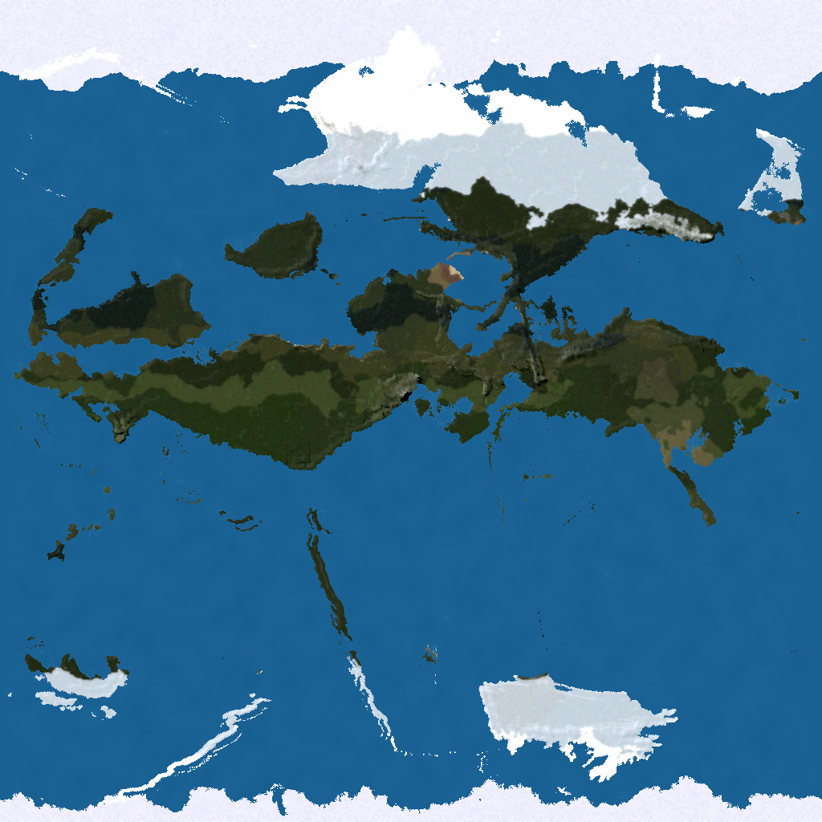

*Created with the Personal Edition of HelpNDoc:* [*Generate EPub eBooks with ease*](http://www.helpndoc.com/create-epub-ebooks)

**Scatter Plot**

# Scatter Plot

The Scatter Plot is different to the other Maps, as it shows a plot of Temperature vs Humidity:

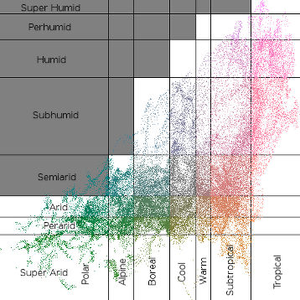

Where Temperature is the X axis getting hotter from Left to Right and Humidity is the Y axis getting more humid from bottom to top.

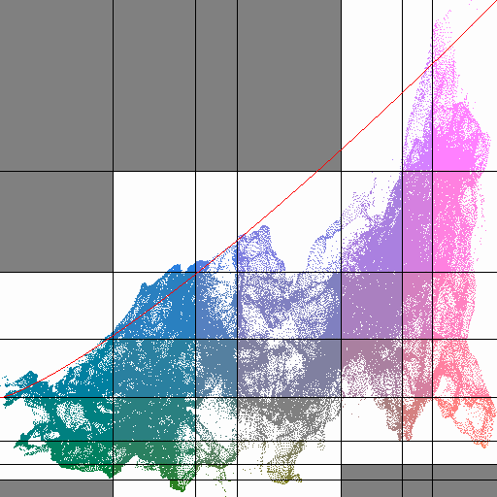

*Created with the Personal Edition of HelpNDoc:* [*Easy CHM and documentation editor*](http://www.helpndoc.com)

**Temperature**

# Temperature

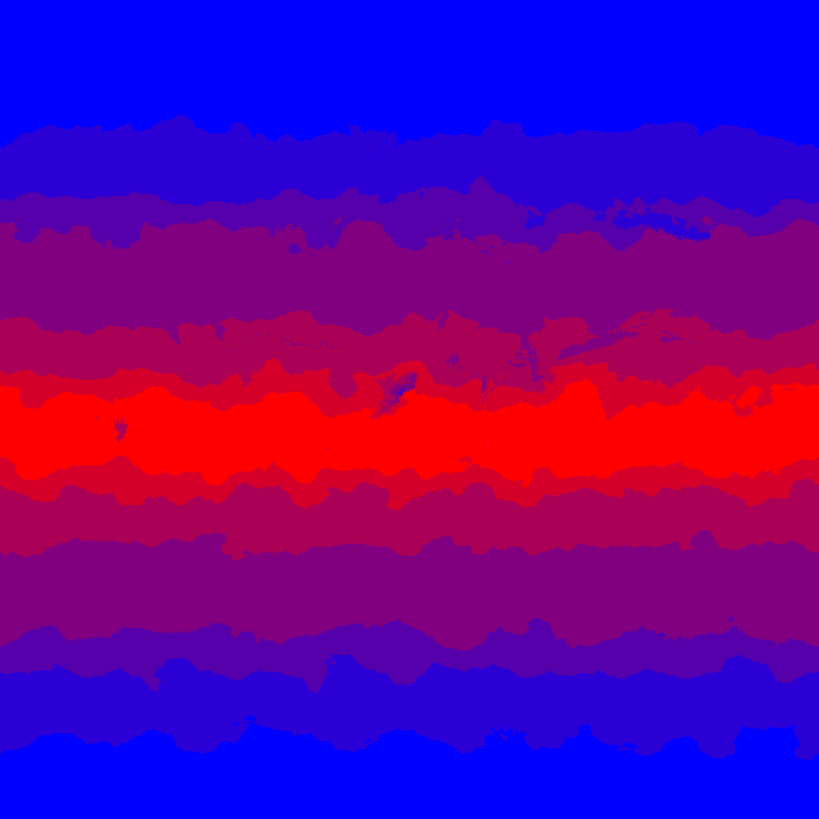

*Created with the Personal Edition of HelpNDoc:* [*Create help files for the Qt Help Framework*](http://www.helpndoc.com/feature-tour/create-help-files-for-the-qt-help-framework)

**Wind**

# Wind

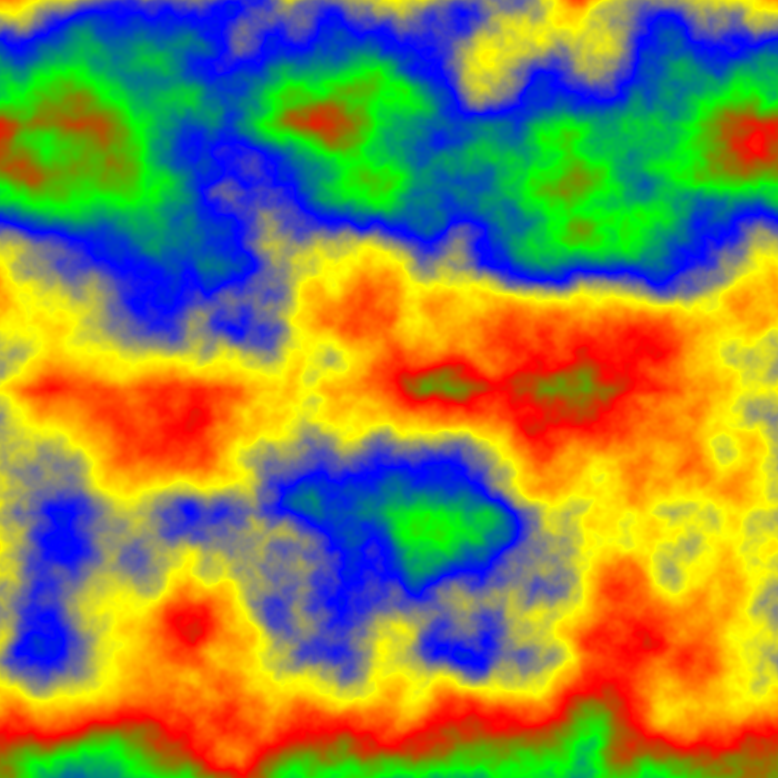

*Created with the Personal Edition of HelpNDoc:* [*Free Qt Help documentation generator*](http://www.helpndoc.com)

**Map Options Tab**

# Map Options

The **Map Options** tab consists of two parts. The uppermost part is what I call the MiniMap, which shows a smaller version of the Main Viewport. The main difference between the MiniMap and the Main Viewport (besides their respective sizes!) is that the MiniMap will ALWAYS show the whole Map, whereas the content of the Main Viewport can be zoomed in, moved, zoomed out etc.

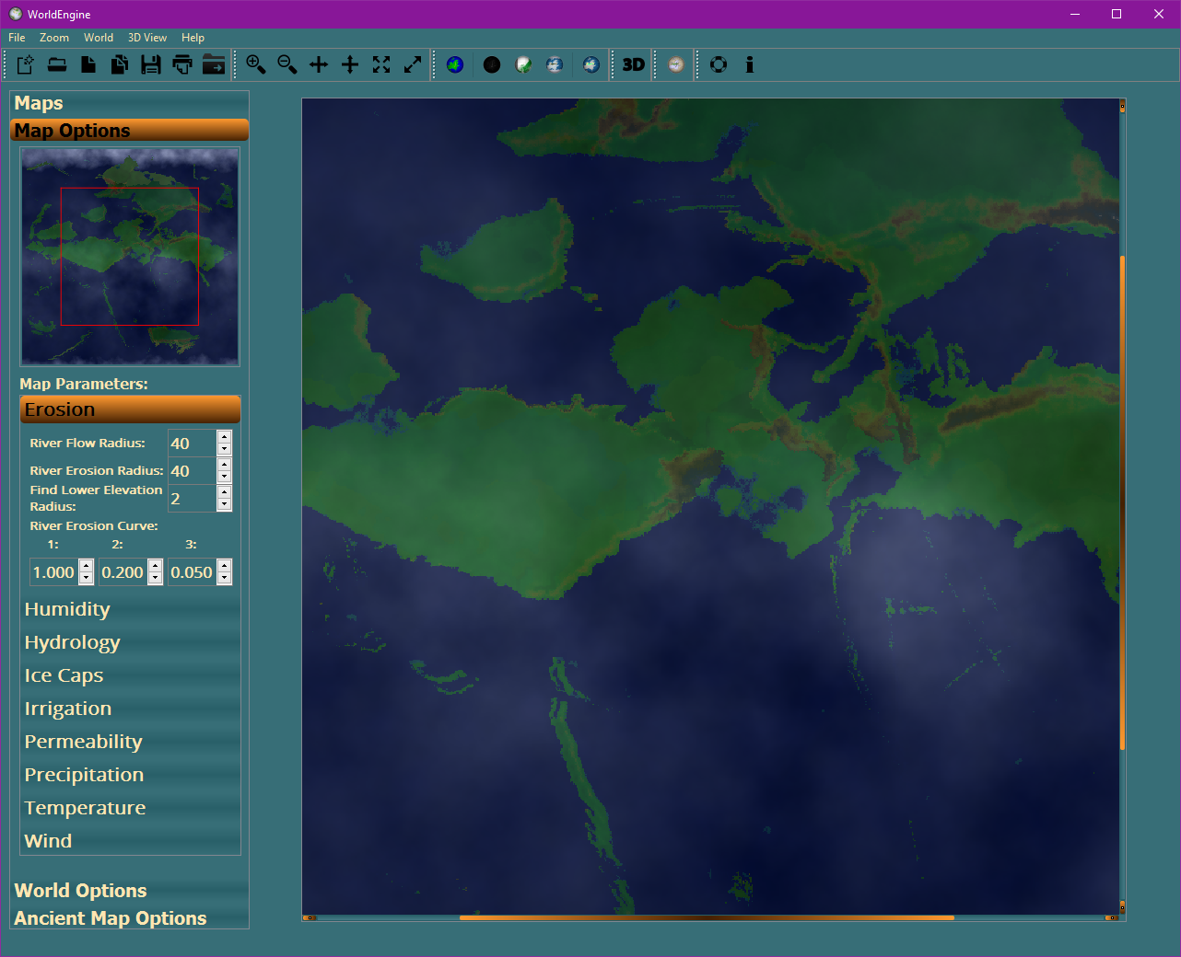

The red rectangle visible in the MiniMap shows the area of the Map that is currently displayed in the Main Viewport.

The lower part of this tab displays the various parameters for the various Simulations. More information on these can be found here.

*Created with the Personal Edition of HelpNDoc:* [*What is a Help Authoring tool?*](http://www.helpauthoringsoftware.com)

**Map Parameters**

# Map Parameters

The **Map Parameters** part of the **Map Options** tab contains tabs for all of the Simulations that have parameters that can be changed:

* Erosion
* Humidity
* Hydrology
* Ice Caps
* Irrigation
* Permeability
* Precipitation
* Temperature
* Wind

*Created with the Personal Edition of HelpNDoc:* [*Full-featured Help generator*](http://www.helpndoc.com/feature-tour)

**Erosion**

# Erosion

The **Erosion** tab has the following options:

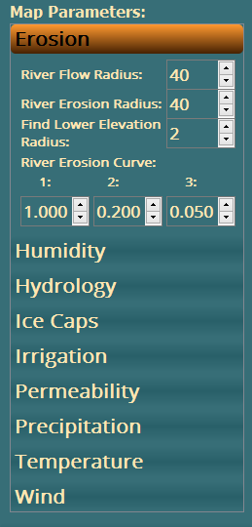

River Flow Radius This is a number representing the Radius of Rivers etc. and is used when calculating the Flow of that River. It must be between **10** and **100**.

River Erosion Radius This is a number representing the Radius of Rivers etc, and is used when calculating the Erosion caused by that River. It must be between **10** and **100**.

Find Lower Elevation

Radius This is a number representing the Radius of a circle to be used to determine if a Lower Elevation exists when calculating the flow of the River etc. It must be between **1** and **100**.

River Erosion Curve This is a series of 3 numbers that set the limits for the amount of Erosion to be applied along the edges of the River. This enables the creation of more Erosion near the River and less further away from the River. Each number must be between **0.010** and **10.000**. NB: The numbers MUST be in **DESCENDING** order.

*Created with the Personal Edition of HelpNDoc:* [*Generate Kindle eBooks with ease*](http://www.helpndoc.com/feature-tour/create-ebooks-for-amazon-kindle)

**Humidity**

# Humidity

The **Humidity** tab has the following options:

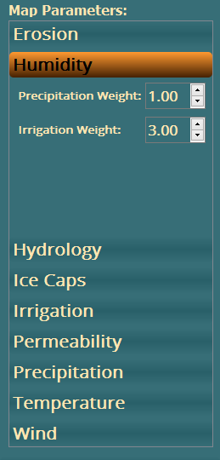

Precipitation Weight This is a number representing the Weighting to be applied for Precipitation. It must be between **0.00** and **99.99**.

Irrigation Weight This is a number representing the Weighting to be applied for Irrigation. It must be between **0.00** and **99.99**.

*Created with the Personal Edition of HelpNDoc:* [*Easy to use tool to create HTML Help files and Help web sites*](http://www.helpndoc.com/help-authoring-tool)

**Hydrology**

# Hydrology

The **Hydrology** tab has the following options:

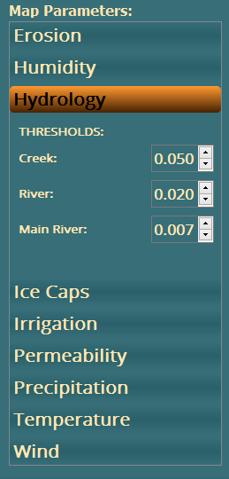

Creek Threshold This is a number representing the Threshold at which Water becomes a Creek. It must be between **0.000** and **1.000**.

River Threshold This is a number representing the Threshold at which Water becomes a River. It must be between **0.000** and **1.000**.

Main River Threshold This is a number representing the Threshold at which Water becomes a Main River. It must be between **0.000** and **1.000**.

NB: The above values MUST be in **DESCENDING** order.

*Created with the Personal Edition of HelpNDoc:* [*Produce electronic books easily*](http://www.helpndoc.com/create-epub-ebooks)

**Ice Caps**

# Ice Caps

The **Ice Caps** tab has the following options:

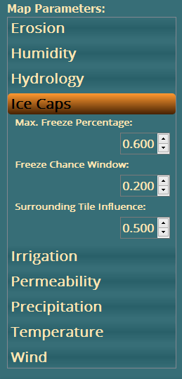

Max. Freeze

Percentage This is a number representing the percentage where only the coldest x% of the cold area will freeze. It must be between **0.000** and **1.000**.

Freeze Chance

Window This is a number representing the percentage where the warmest x% of the freezable area won't completely freeze. It must be between **0.000** and **1.000**.

Surrounding Tile

Influence This is a number representing a percentage chance to freeze a slightly warm tile when it's neighbouring Tiles are frozen. It must be between **0.000** and **1.000**.

*Created with the Personal Edition of HelpNDoc:* [*Full-featured EPub generator*](http://www.helpndoc.com/create-epub-ebooks)

**Irrigation**

# Irrigation

The **Irrigation** tab has the following options:

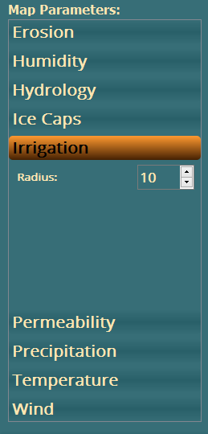

Radius This is a number representing the Radius of a circle used to determine which areas of the Map are used in the Irrigation calculation. It must be between **1** and **100**.

*Created with the Personal Edition of HelpNDoc:* [*Easily create EPub books*](http://www.helpndoc.com/feature-tour)

**Permeability**

# Permeability

The **Permeability** tab has the following options:



Low Threshold This is a number representing the Threshold at which Permeability is Low. It must be between **0.000** and **1.000**.

Medium Threshold This is a number representing the Threshold at which Permeability is Medium. It must be between **0.000** and **1.000**.

Octaves This is a number representing the Number of Octaves used in the Noise generation part of the Permeability calculation. It must be between **0** and **99**.

Frequency This is a number representing the Frequency used in the Noise generation part of the Permeability calculation. It must be between **0.0** and **256.0**. NB: Preferably in steps of **8**.

NB: The Low Threshold MUST be a **HIGHER** value than the Medium Threshold.

*Created with the Personal Edition of HelpNDoc:* [*Create iPhone web-based documentation*](http://www.helpndoc.com/feature-tour/iphone-website-generation)

**Precipitation**

# Precipitation

The **Precipitation** tab has the following options:

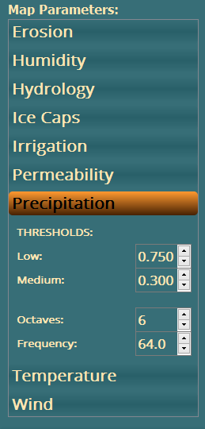

Low Threshold This is a number representing the Threshold at which Precipitation is Low. It must be between **0.000** and **1.000**.

Medium Threshold This is a number representing the Threshold at which Precipitation is Medium. It must be between **0.000** and **1.000**.

Octaves This is a number representing the Number of Octaves used in the Noise generation part of the Precipitation calculation. It must be between **0** and **99**.

Frequency This is a number representing the Frequency used in the Noise generation part of the Precipitation calculation. It must be between **0.0** and **256.0**. NB: Preferably in steps of **8**.

NB: The Low Threshold MUST be a **HIGHER** value than the Medium Threshold.

*Created with the Personal Edition of HelpNDoc:* [*Free EBook and documentation generator*](http://www.helpndoc.com)

**Temperature**

# Temperature

The **Temperature** tab has the following options:

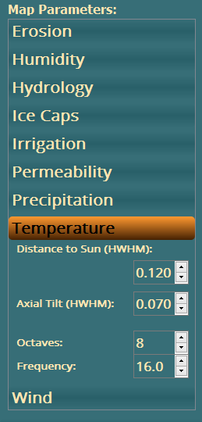

Distance to Sun

(HWHM) This is a number representing the Distance between the Sun and the World. It must be between **0.000** and **1.000**. NB: An Earth-like planet = **1.0** and the realistic range should be between **~0.7** and **~1.3** (see <https://en.wikipedia.org/wiki/Circumstellar_habitable_zone>)

Axial Tilt (HWHM) This is a number representing the Axial Tilt of the World. It must be between **0.000** and **1.000**. NB: The World will usually move around its star at an angle (see <https://en.wikipedia.org/wiki/Axial_tilt>) and a value of **0.5** here would refer to an angle of **90** degrees (Uranus-style - see <https://en.wikipedia.org/wiki/Uranus>). This value should usually be in the range -**0.15 < Axial Tilt < 0.15** for a habitable World.

Octaves This is a number representing the Number of Octaves used in the Noise generation part of the Temperature calculation. It must be between **0** and **99**.

Frequency This is a number representing the Frequency used in the Noise generation part of the Temperature calculation. It must be between **0.0** and **256.0**. NB: Preferably in steps of **8**.

NB: HWHM means "Half Width at Half Maximum" and is used in the Gaussian calculations.

*Created with the Personal Edition of HelpNDoc:* [*Easily create Web Help sites*](http://www.helpndoc.com/feature-tour)

**Wind**

# Wind

The **Wind** tab has the following options:

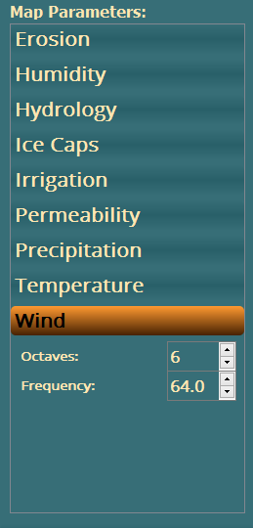

Octaves This is a number representing the Number of Octaves used in the Noise generation part of the Wind calculation. It must be between **0** and **99**.

Frequency This is a number representing the Frequency used in the Noise generation part of the Wind calculation. It must be between **0.0** and **256.0**. NB: Preferably in steps of **8**.

*Created with the Personal Edition of HelpNDoc:* [*Full-featured Help generator*](http://www.helpndoc.com/feature-tour)

**World Options Tab**

# World Options

The **World Options** tab allows the setting of many parameters for the creation of the world.

It consists of 5 Sub-Tabs:

**Basic World Options** - this Sub-Tab lets you set the following options:

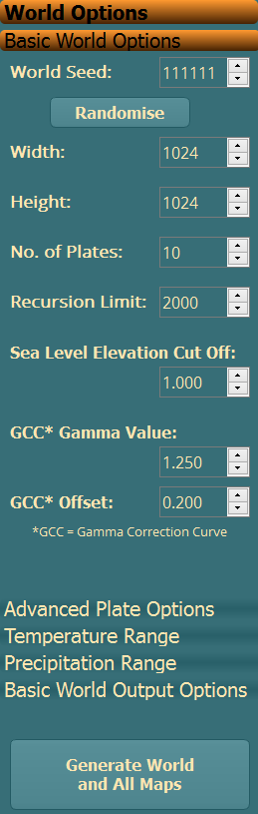

World Seed This is a number representing the Base of the world. It must be between **1** and **65535**. You can use the **Randomise** button to generate a random number.

Width This is a number representing the number of Pixels for the Width of the world. It must be between **256** and **8192**. NB: This should also be divisible by **8**.

Height This is a number representing the number of Pixels for the Height of the world. It must be between **256** and **8192**. NB: This should also be divisible by **8**.

No. of Plates This is a number representing the number of Tectonic Plates in the world. It must be between **1** and **100**. NB: A value of **1** will not really do much as there will be no plate collision.

Recursion Limit This is a number representing the number of Recursive Loops to be carried out when generating the world. It must be between **1.000** and **10.000**.

GCC Gamma Value This is a number that determines the Gamma Value for the Gamma Correction Curve. It must be between **0.000** and **99.990**.

GCC Offset This is a number that determines the Offset Value for the Gamma Correction Curve. It must be between **0.000** and **0.999**.

Sea Level Elevation

Cut Off This is a number representing the level at which Sea becomes Land. It must be between **1.000** and **99.990**.

**Advanced Plate Options** - this Sub-Tab is for advanced users and lets you set the following options:

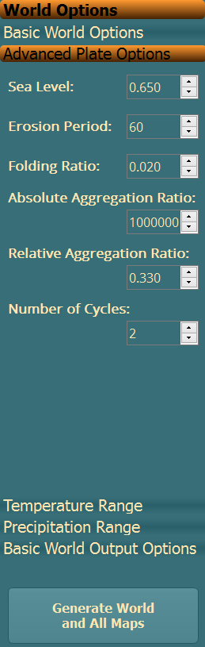

Sea Level This sets the percentage of dry land before any tectonic simulation has taken place. It must be between **0.000** and **1.000**.

NB: A value of **0.000** indicates a world covered with water. Plate tectonics would bring forth islands that would later merge into continents.

A value of **1.000** indicates a world that's devoid of any oceanic crust, being completely filled with continents, and would cause plate tectonics to halt at the very first steps.

Erosion Period This sets the number of iterations (i.e. the number of consecutive calls to update method that should pass between sequential runs) of the erosion algorithm. It must be between **0** and **100**.

NB: A value of **0.000** indicates that erosion is never applied to the system.

Folding Ratio This sets the amount of crust that is moved from the source plate to the destination plate at the location where two plates overlap. It must be between **0.000** and **1.000**.

NB: A value of **0.000** indicates that nothing is transferred.

A value of **1.000** causes everything to be transferred immediately.

NB2: The destination plate is that which has a larger continent at the location of collision.

Absolute Aggregation

Ratio This sets the minimum amount of surface area that one continent on a plate must overlap with another continent on another plate during that iteration before the two continents are merged into one continent that resides on either plate. The smaller continent will always be merged to the larger one. It must be between **0** and **10,000,000**.

Relative Aggregation

Ratio This sets the minimum percentage of surface area of a continent that must overlap with another continent before they are merged into one continent. It must be between **0.000** and **1.000**.

NB: A value of **0.000** would cause two colliding continents to become merged immediately.

A value of **1.000** requires that the smaller plate is completely beneath the larger plate before they are merged together.

NB2: This parameter plays a central role when the rate of continental growth is adjusted.

Number of Cycles This sets the maximum number of times that the lithosphere is divided into plates. It must be between **0.000** and **1.000**.

NB: A value of **0.000** indicates that a new set of plates is generated instead of the old ones every time the sum of plate movement slows down too much.

These variables, along with the number of plates, control the behaviour of the Plates Model and will affect its outcome greatly.

**Temperature Range** - this Sub-Tab lets you set the following options:

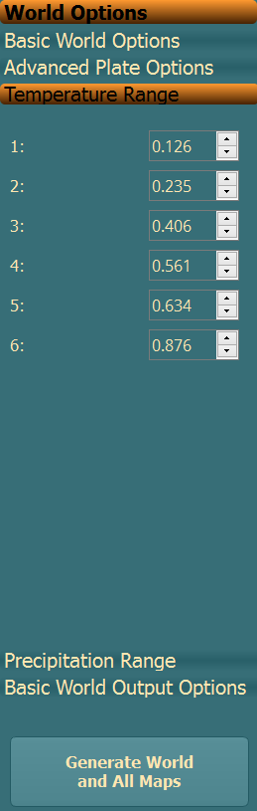

Temperature Range This is a series of 6 numbers that set the limits for the different Temperature Levels. Each number must be between **0.000** and **1.000**. NB: The numbers MUST be in **ASCENDING** order.

**Precipitation Range** - this Sub-Tab lets you set the following options:

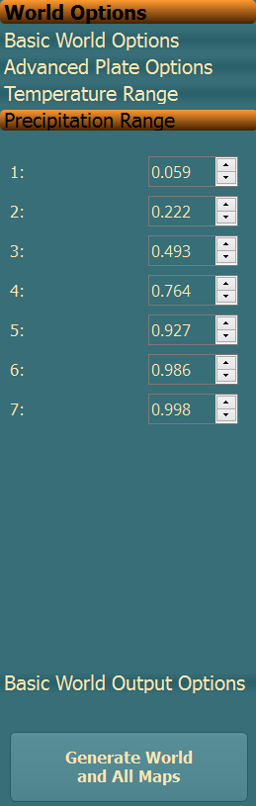

Precipitation Range This is a series of 7 numbers that set the limits for the different Precipitation Levels. Each number must be between **0.000** and **1.000**. NB: The numbers MUST be in **ASCENDING** order.

**Basic World Output Options** - this Sub-Tab lets you set the following options:

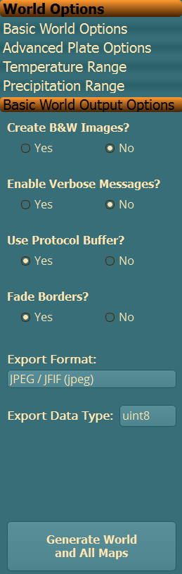

Create B&W Images? This is a simple Yes/No choice and determines whether some of the Maps should be in Black & White or Colour.

Enable Verbose

Messages? This is a simple Yes/No choice and determines whether the pop-up shows more detail when generating the world.

Use Protocol Buffer? This is a simple Yes/No choice and determines whether to use the Google Protocol Buffer, or HDF5 to store the world data. NB: HDF5 generates a smaller world file.

Fade Borders? This is a simple Yes/No choice and determines whether to fade out the borders of the world.

Export Format This is a drop-down allowing the selection of the Format for the Maps. This contains the usual image formats (png, jpg, gif etc.) as well as many cartography formats (Erdas Image, ERMapper etc.)

Export Data Type This is a drop-down allowing the selection of the Data Type for the Maps. This contains many options from **uint8** (unsigned 8 bit integer) to **float64** (64 bit floating point).

Finally, beneath the Tabs there is a button labelled **Generate World and All Maps** which basically does exactly what it says, generates the World and ALL Maps.

*Created with the Personal Edition of HelpNDoc:* [*Free help authoring tool*](http://www.helpndoc.com/help-authoring-tool)

**Ancient Map Options Tab**

# Ancient Map Options

The **Ancient Map Options** Tab provides several options that ONLY apply to the generation of an Ancient World Map:

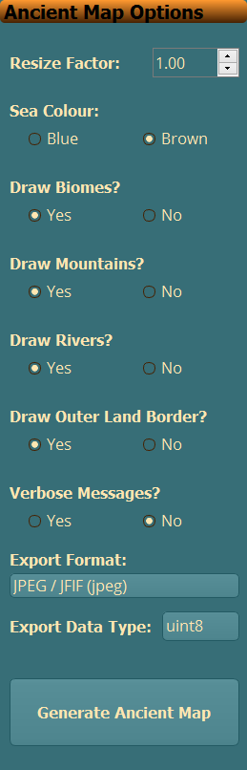

Resize Factor This is a number that determines the Factor by which the Ancient World Map should be Larger than the standard. It must be between **1.00** and **99.99**.

Sea Colour This is a choice between "Blue" and "Brown" to determine the colour of the Oceans of the Ancient World Map.

Draw Biomes? This is a simple Yes/No choice and determines whether Biomes should be drawn on the Ancient World Map, or not.

Draw Mountains? This is a simple Yes/No choice and determines whether Mountains should be drawn on the Ancient World Map, or not.

Draw Rivers? This is a simple Yes/No choice and determines whether Rivers should be drawn on the Ancient World Map, or not.

Draw Outer Land

Borders? This is a simple Yes/No choice and determines whether the Outer Land Borders should be drawn on the Ancient World Map, or not.

Verbose Messages? This is a simple Yes/No choice and determines whether the pop-up should display more information when generating the Ancient World Map, or not.

Export Format This is a drop-down allowing the selection of the Format for the Ancient World Map. This contains the usual image formats (png, jpg, gif etc.) as well as many cartography formats (Erdas Image, ERMapper etc.)

Export Data Type This is a drop-down allowing the selection of the Data Type for the Ancient World Map. This contains many options from **uint8** (unsigned 8 bit integer) to **float64** (64 bit floating point).

Finally, there is a button labelled **Generate Ancient Map** which basically does exactly what it says, generates the Ancient World Map. NB: Clicking the button labelled **Generate World and All Maps** on either of the **World Options** tabs will also generate the Ancient World Map.

*Created with the Personal Edition of HelpNDoc:* [*Easy Qt Help documentation editor*](http://www.helpndoc.com)

**Ancient World Map**

# Ancient World Map

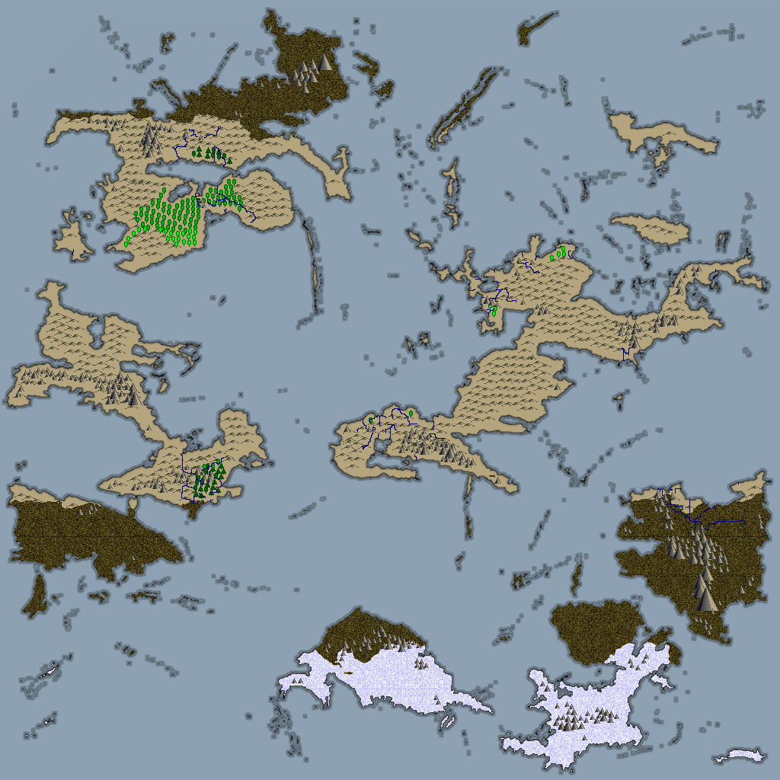

*Created with the Personal Edition of HelpNDoc:* [*Full-featured EPub generator*](http://www.helpndoc.com/create-epub-ebooks)

**Menus**

# Menus

There are several Menus available at the top of the UI:

File

Zoom

World

3D View

Help

Note that all Menu options can also be accessed by a Shortcut Key combination. See the relevant Menu for full details.

*Created with the Personal Edition of HelpNDoc:* [*Free EBook and documentation generator*](http://www.helpndoc.com)

**File**

# File Menu

This is a fairly standard **File** Menu, so I'll only point out a couple of options.

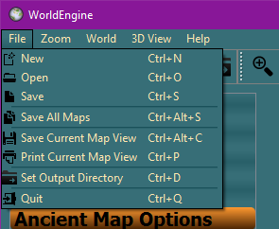

Save Current Map View This allows the saving of the current view of the Map as displayed in the Main Viewport of the UI.

Print Current Map View This allows the printing of the current view of the Map as displayed in the Main Viewport of the UI.

Set Output Directory This allows the setting of the Directory to be used for ALL output (world, maps etc.).

*Created with the Personal Edition of HelpNDoc:* [*Easy Qt Help documentation editor*](http://www.helpndoc.com)

**Zoom**

# Zoom Menu

This menu contains several options for quickly changing how the map is displayed in the Main Viewport.

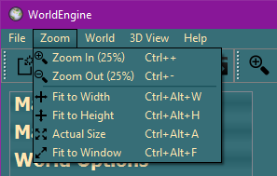

All of the options should be fairly self explanatory.

*Created with the Personal Edition of HelpNDoc:* [*Easily create EPub books*](http://www.helpndoc.com/feature-tour)

**World**

# World Menu

This is a fairly self explanatory menu that allows several World options.

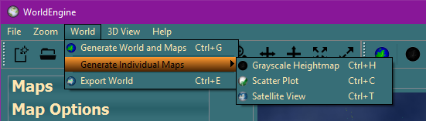

The only option I'll mention is:

Export World This option allows the current World to be exported using the selected Default Directory, Format and Data Type.

*Created with the Personal Edition of HelpNDoc:* [*Create HTML Help, DOC, PDF and print manuals from 1 single source*](http://www.helpndoc.com/help-authoring-tool)

**3D View**

# 3D View Menu

This menu contains one option that opens up the 3D View of the World.

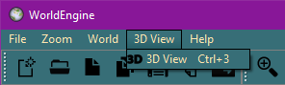

Once you have clicked on **3D View**, you will see another Window that contains a representation of your World in glorious 3D (courtesy of Pi3D - <http://pi3d.github.io/html/ReadMe.html> - with thanks to Tim, Paddy & Tom):

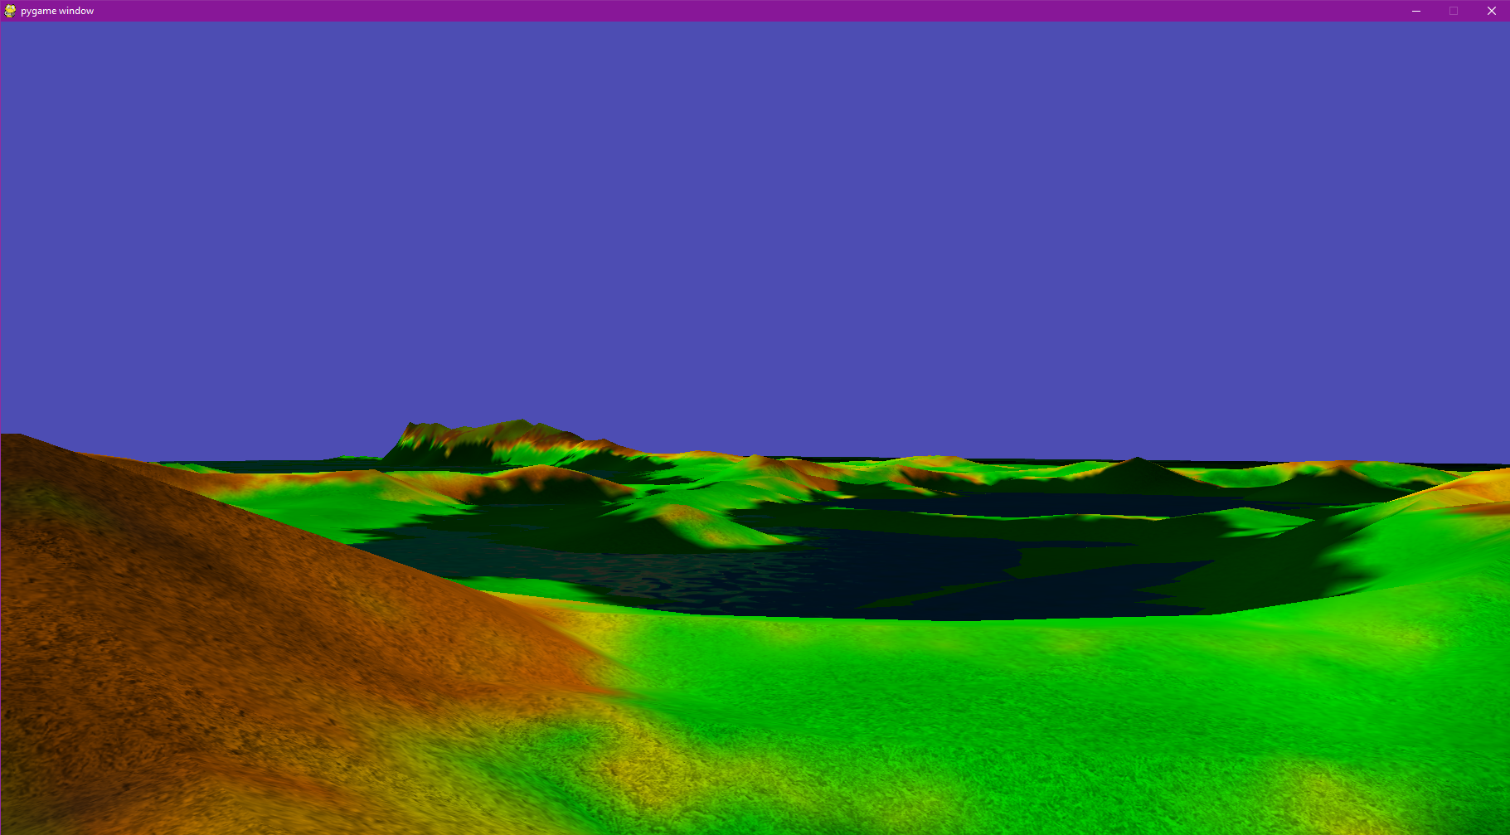

Note that this is extremely limited in that it only shows the one texture (If anyone is a whizz with Pi3D/PyGame, please feel free to add more textures to properly show Oceans, Rivers, Mountains etc.), but it does give you a general idea of what your World will look like.

To move around, use the following:

Mouse To **ROTATE RIGHT** & **LEFT** and to **LOOK UP** & **DOWN**

W Key To move **FORWARDS**

S Key To move **BACKWARDS**

R Key To move **UPWARDS** NB: Once you release this Key, you will slowly fall back to ground level.

T Key To move **DOWNWARDS** NB: This Key allows you to get back to ground level faster than normal.

0 Key To **EXIT** and return to the GUI NB: The 3D View window will capture ALL Keyboard and Mouse inputs and restrict movement to within the bounds of the window. The only way to exit is to either use the **0** Key, or **Ctrl-Tab** to another window.

*Created with the Personal Edition of HelpNDoc:* [*Free EBook and documentation generator*](http://www.helpndoc.com)

**Help**

# Help Menu

This is a standard **Help** Menu.

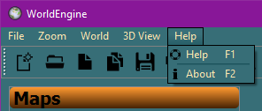

*Created with the Personal Edition of HelpNDoc:* [*Easily create Help documents*](http://www.helpndoc.com/feature-tour)

**Toolbars**

# Toolbars

Directly underneath the Menus are the Toolbars.



The options in the Toolbars basically mirror the options in the Menus.

The first Toolbar is the **File Toolbar** and has the same options as the File Menu, with one exception, there is no **Quit** option.



New

Open

Save

Save All

Save Current Map View

Print Current Map View

Set Output Directory

The second Toolbar is the **Zoom Toolbar** and has the same options as the Zoom Menu.



Zoom In (25%)

Zoom Out (25%)

Fit to Width

Fit to Height

Actual Size

Fit to Window

The third Toolbar is the **World Toolbar** and has the same options as the World Menu with one exception, the **Ancient World** button has it's own Toolbar (see below).



Generate World and Maps

Generate Grayscale Heightmap

Generate Scatter Plot

Generate Satellite View

Export World

The fourth Toolbar is the **3D View Toolbar** and has the same option as the 3D View Menu.



3D View

The fifth Toolbar is the **Ancient World Toolbar**.

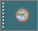

Generate Ancient World

The sixth, and final, toolbar is the **Help Toolbar** and has the same options as the Help Menu.



Help

About

*Created with the Personal Edition of HelpNDoc:* [*Easily create HTML Help documents*](http://www.helpndoc.com/feature-tour)